
SCHOOL OF COMPUTING AND ENGINEERING SCIENCES (SCES)
BACHELOR OF SCIENCE IN ELECTRICAL AND ELECTRONICS ENGINEERING (BSEEE)
BEE 3206: CONTROL SYSTEMS_1 Lab 4
GROUP 5
Report By:
Mwongela Edward Aribu
142092

LECTURER: PROF. MWANGI MBUTHIA
LABORATORY TECHNOLOGIST: MR. JAMLICK NTOJIRA
21st December 2023

Table of Contents
List of figures 2
Title: Robot Car Racing Competition 3
Abstract 3
Introduction 3
KS0559(KS0559F) Keyestudio 4WD BT Multi-purpose Car V2.0 3
Electric motor rating 3
(Weight) Mass 3
Aerodynamic Drag 4
Methods and Materials 5
Assumptions 5
Objective 5
Procedure 5
Electric Racing Car code 7
MATLAB code 14
Results 17
Discussion and Conclusion 28

List of figures
Figure 1 5
Figure 2 6
Figure 3 16
Figure 4 16
Figure 5 table showing the autocross speed and time values every 0.2 seconds for one lap. 26
Figure 6 lab 4 Matlab experimental graph 27
Figure 7 lab 3 Matlab experimental graph 27

Title: Robot Car Racing Competition

Abstract
The aim of this lab is to autonomously drive a robot car round a 40m racing track, determine the Robot car lap time, learn how to use a program with both speed and direction feedback to autonomously drive a robot car round 40m racing track.

Introduction

KS0559(KS0559F) Keyestudio 4WD BT Multi-purpose Car V2.0
The KS0559(KS0559F) Keyestudio 4WD BT Multi-purpose Car V2.0 is one of the most popular Arduino sets. It has a stunning appearance as well as powerful functions. Furthermore, you can build your own projects or add other sensors to finish your research. Most of the components are connected by screws and copper pillars, allowing you to build your own robot in a few simple steps. Furthermore, we may master the fundamentals of line tracking, obstacle avoidance sensors, ultrasonic ranging, Bluetooth connection, motor drivers, and IR remote controls. This bundle includes 17 learning projects ranging from simple to sophisticated that will walk you through the process of building an Arduino robot.

Electric motor rating
Power Output: A car's acceleration and top speed are directly influenced by the electric motor rating, which is commonly expressed in kW or HP. A more powerful motor will generate more torque and acceleration, allowing the vehicle to accelerate faster.
Torque: Electric motors instantly produce torque, which helps them accelerate quickly. More torque can be produced by motors with higher ratings, allowing for speedier acceleration from stopping position.
Efficiency: The electric motor's capacity to maintain high speeds can be impacted by its efficiency. More effective motors can operate at high speeds for extended periods of time while wasting less energy as heat.

(Weight) Mass
Inertia: A car's mass influences its ability to accelerate and decelerate. Heavier vehicles have greater inertia, requiring more force to accelerate and stop. As a result, acceleration will be slower and braking distances will be greater.
Momentum: Once an automobile is moving, its mass has an impact on its capacity to maintain speed. Heavier vehicles have more momentum, making it more difficult to change speed or direction. This can influence a vehicle's agility and reactivity at greater speeds.

Aerodynamic Drag
Aerodynamic drag is a force that resists the motion of the car as it passes through the air. The drag coefficient measures how aerodynamic the shape of a car is. Lower drag coefficients minimise the resistance the car faces, allowing it to travel faster while using less power.
Cross-Sectional Area: The frontal area of the car influences aerodynamic drag as well. Larger cross-sectional areas generate more air resistance, which limits top speed and may reduce acceleration.
Speed Restrictions: As an automobile speeds, aerodynamic drag increases. Overcoming air resistance at high speeds necessitates additional power. Cars with lower drag coefficients operate better at high speeds

Methods and Materials

Assumptions
- An Electric Racing Car is driven around a flat racing track shown in figure 1.
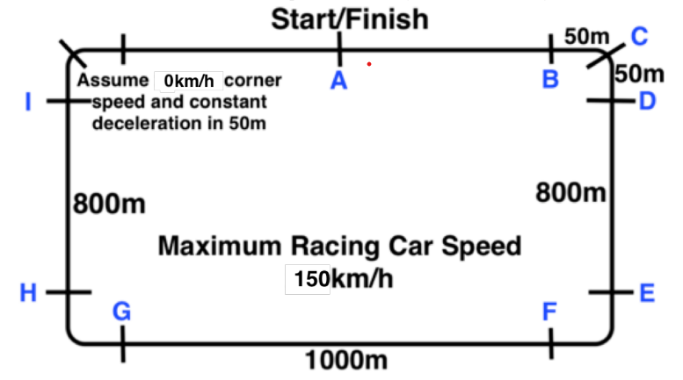
Figure 1
- The racing car is modelled as a simple Cart on wheels.
- Assume the Racing Car Longitudinal dynamics is modelled using the LDE where M is the lamped car mass, v is the car speed in m/s, b is the aerodynamic drag coefficient proportional to the speed and F is the force produced by the electric motor.

Objective
- Autonomously drive a robot car round a 40m racing track
- Determine the Robot car lap time
- Learn how to use a program with both speed and direction feedback to autonomously drive a robot car round 40m racing track.

Procedure
- You will use tape to mark out a 40m track on a surface of your choice (for the competition, all teams will use the Basketball Court). Use tape to mark the points A, B, C, D, L, E, F, G, H, and I as shown in Fig. 1
- Write code to autonomously drive the robot car on the track prepared in 4.2.1 along path A, B, C, D, L
- Write code to autonomously drive the robot car on the track prepared in 4.2.1 along the path A, B, C, D, E, F, G, H, I, A.
- Train your group robot car autonomous driving code on the racing track and make code adjustments to keep it within the track and achieve the best Lap time. Save values of speed and time every 0.2 seconds.
- Each group MUST upload a video of the best Skid Test and Autocross autonomous driving of your Robot Car and state the best lap time before the day of competition. Compare the lap time with the values obtained using MATLAB in Lab 3.
- Upload a table showing the autocross speed and time values every 0.2 seconds for one lap.
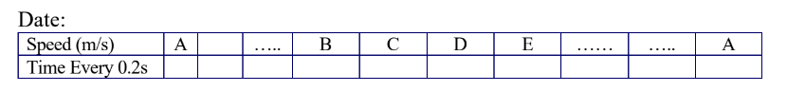
Figure 2
- Use the values recorded in 5.2.3 to plot the speed vs time values for the section A to B and draw the best curve fit during acceleration to steady state speed. Using your graph, obtain a new set of values of damping coefficient b (Ns/m) and motor Force F (N) for your robot car and compare them with the b and F values obtained in Lab_3.
- Include your autonomous driving code for your robot in the report.

Electric Racing Car code
#define ML_Ctrl 4 // define the direction control pin of B motor
#define ML_PWM 5 //define the PWM control pin of B motor
#define MR_Ctrl 2 //define direction control pin of A motor
#define MR_PWM 6 //define the PWM control pin of A motor
#define encoderPin 9 //define encoder input pin

int pulsesPerRevolution = 20; // Number of pulses per revolution of the wheel
float wheelCircumference = 20.4; // Wheel circumference in cm
float arcLength = 1.02; // Arc length in cm [circumference/(holes)]
float totalDistance = 0; //Total Distance in m
unsigned long StartMillis = 0;
unsigned long stopMillis = 0;
unsigned long period = 0;
volatile bool B_State = 0;
volatile bool A_State = 0;
volatile byte B_PWM = 0;
volatile byte A_PWM = 0;
volatile bool Start = 0;
bool S2 = 0;
bool S3 = 0;
bool S4 = 0;
bool S5 = 0;
bool S6 = 0;
bool S7 = 0;
bool S8 = 0;
bool S9 = 0;

float S1_Distance = 5;
float S2_Distance = 1.1;
float S3_Distance = 8;
float S4_Distance = 1.1;
float S5_Distance = 10.0;
float S6_Distance = 1.;
float S7_Distance = 8.0;
float S8_Distance = 1.1;
float S9_Distance = 5.0;
bool stop = 1;
void setup()
{
Serial.begin(9600);

pinMode(ML_Ctrl, OUTPUT);//set direction control pin of B motor to output
pinMode(ML_PWM, OUTPUT);//set PWM control pin of B motor to output
pinMode(MR_Ctrl, OUTPUT);//set direction control pin of A motor to output
pinMode(MR_PWM, OUTPUT);//set the PWM control pin of A motor to output
pinMode(encoderPin, INPUT);
digitalWrite(ML_Ctrl, HIGH);
digitalWrite(MR_Ctrl, HIGH);
}
void loop()
{
StartMillis = millis();

if (stop && !Start) //5
{
totalDistance = 0;
//Start
//Serial.println("Start: Sector 1");
digitalWrite(ML_Ctrl, HIGH);
analogWrite(ML_PWM, 100);
digitalWrite(MR_Ctrl, HIGH);
analogWrite(MR_PWM, 104);
Start = 1;
}

else if (Start && totalDistance >= S1_Distance && !S2 ) //2.2
{
//Turn
//Serial.println("Turn 180: Sector 2");
digitalWrite(ML_Ctrl, HIGH);
analogWrite(ML_PWM, 120); //B
digitalWrite(MR_Ctrl, HIGH);
analogWrite(MR_PWM, 73); //
S2 = 1;
}
else if (Start && S2 && totalDistance >= (S1_Distance + S2_Distance) && !S3) //8
{
// Sector 3
//Serial.println("Sector 3");
digitalWrite(ML_Ctrl, HIGH);
analogWrite(ML_PWM, 100);
digitalWrite(MR_Ctrl,HIGH);
analogWrite(MR_PWM, 104);
S3 = 1;
}
else if (Start && S2 && S3 && totalDistance >= (S1_Distance + S2_Distance + S3_Distance) && !S4) //2.2
{
//Turn
//Serial.println("Turn 180: Sector 2");
digitalWrite(ML_Ctrl, HIGH);
analogWrite(ML_PWM, 120); //B
digitalWrite(MR_Ctrl, HIGH);
analogWrite(MR_PWM, 73); //
S4 = 1;
}
else if (Start && S2 && S3 && S4 && totalDistance >= (S1_Distance + S2_Distance + S3_Distance + S4_Distance) && !S5) //10.0
{
// Sector 3
//Serial.println("Sector 3");
digitalWrite(ML_Ctrl, HIGH);
analogWrite(ML_PWM, 100);
digitalWrite(MR_Ctrl,HIGH);
analogWrite(MR_PWM, 104);
S5 = 1;
}
else if (Start && S2 && S3 && S4 && S5 && totalDistance >= (S1_Distance + S2_Distance + S3_Distance + S4_Distance + S5_Distance) && !S6) //2.2
{
//Turn
//Serial.println("Turn 180: Sector 2");
digitalWrite(ML_Ctrl, HIGH);
analogWrite(ML_PWM, 127); //B
digitalWrite(MR_Ctrl, HIGH);
analogWrite(MR_PWM, 73); //
S6 = 1;
}
else if (Start && S2 && S3 && S4 && S5 && S6 && totalDistance >= (S1_Distance + S2_Distance + S3_Distance + S4_Distance + S5_Distance + S6_Distance) && !S7) //8.0
{
// Sector 3
//Serial.println("Sector 3");
digitalWrite(ML_Ctrl, HIGH);
analogWrite(ML_PWM, 100);
digitalWrite(MR_Ctrl,HIGH);
analogWrite(MR_PWM, 104);
S7 = 1;
}
else if (Start && S2 && S3 && S4 && S5 && S6 && S7 && totalDistance >= (S1_Distance + S2_Distance + S3_Distance + S4_Distance + S5_Distance + S6_Distance + S7_Distance) && !S8) //2.2
{
//Turn
//Serial.println("Turn 180: Sector 2");
digitalWrite(ML_Ctrl, HIGH);
analogWrite(ML_PWM, 120); //B
digitalWrite(MR_Ctrl, HIGH);
analogWrite(MR_PWM, 73); //
S8 = 1;
}
else if (Start && S2 && S3 && S4 && S5 && S6 && S7 && S8 && totalDistance >= (S1_Distance + S2_Distance + S3_Distance + S4_Distance + S5_Distance + S6_Distance + S7_Distance + S8_Distance) && !S9) //5
{
// Sector 3
//Serial.println("Sector 3");
digitalWrite(ML_Ctrl, HIGH);
analogWrite(ML_PWM, 100);
digitalWrite(MR_Ctrl,HIGH);
analogWrite(MR_PWM, 104);
S9 = 1;
}

else if (Start && S2 && S3 && S4 && S5 && S6 && S7 && S8 && S9 && totalDistance >= (S1_Distance + S2_Distance + S3_Distance + S4_Distance + S5_Distance + S6_Distance + S7_Distance + S8_Distance + S9_Distance))
{
//Stop
//Serial.println("Stop");
B_State = 0;
A_State = 0;
B_PWM = 0;
A_PWM = 0;
digitalWrite(ML_Ctrl, LOW);
analogWrite(ML_PWM, 0);
digitalWrite(MR_Ctrl, LOW);
analogWrite(MR_PWM, 0);
stop = 0;
Start = 0;
}

// Measure the time duration of a HIGH pulse on the encoder pin
unsigned long durationHigh = pulseIn(encoderPin, HIGH, 2000000);
unsigned long durationLow = pulseIn(encoderPin, LOW, 2000000);
unsigned long duration = durationLow + durationHigh;

// Calculate speed (metres per second)
float speed = ((arcLength * 10000) / duration);

// Print results
//Serial.print("Speed (m/s): ");
Serial.print(speed, 4);

// Calculate distance (cm) based on the number of pulses per revolution
stopMillis = millis();

period = stopMillis - StartMillis;

if (duration >= (period * 500))
{
float distance = ((period * arcLength) / duration) * 10.0;
//Serial.print("\tDistance (m): ");
Serial.print("\t");
Serial.print(distance, 4);

totalDistance = totalDistance + distance;
//Serial.print("\tTotal distance (m): ");
Serial.print("\t");
Serial.println(totalDistance, 4);
}
else
{
float distance = ((period * arcLength) / (period * 500)) * 10.0;
//Serial.print("\tDistance (m): ");
Serial.print("\t");
Serial.print(distance, 4);

totalDistance = totalDistance + distance;
//Serial.print("\tTotal distance (m): ");
Serial.print("\t");
Serial.println(totalDistance, 4);
}
}

MATLAB code
>> % Define the model equation with a fixed value for m (0.636 in this case)
model = @(params, t) params(1)./params(2) * (1 - exp(-params(2)*t/0.636));

% Provided experimental data
t = [0.0, 0.616, 0.819, 1.096, 1.219, 1.421, 1.632, 1.828, 1.991, 2.236, 2.441, 2.606, 2.837, 3.01, 3.271, 3.403, 3.600, 3.811, 4.068, 4.272, 4.405, 4.608, 4.801, 5.078, 5.209, 5.484, 5.685, 5.809, 6.09, 6.212];
v = [0.2758, 0.2758, 0.3225, 0.3225, 0.3225, 0.3339, 0.3339, 0.3346, 0.3262, 0.2928, 0.303, 0.3278, 0.2898, 0.2898, 0.303, 0.2912, 0.303, 0.3329, 0.3329, 0.3322, 0.3179, 0.2942, 0.2975, 0.2975, 0.3383, 0.2758, 0.2758, 0.3225, 0.3225, 0.3225];

% Use lsqcurvefit to fit the model to the data with initial guesses
initial_guess = [1.0, 1.0]; % You might need to adjust these initial guesses
params = lsqcurvefit(@(params, t) model(params, t), initial_guess, t, v);

% Extract the fitted parameters
F_fit = params(1);
b_fit = params(2);

% Generate a higher-resolution time vector
t_highres = linspace(min(t), max(t), 1000);

% Generate theoretical values using the fitted parameters
v_fit = model(params, t_highres);

% Plot the experimental data and the fitted curve
figure;
scatter(t, v, 'o', 'DisplayName', 'Experimental Data');
hold on;
plot(t_highres, v_fit, 'LineWidth', 2, 'DisplayName', 'Fitted Curve');

xlabel('Time (s)');
ylabel('Velocity (m/s)');
title('Wheel On Carts');

% Add annotations for F_fit and b_fit
annotation('textbox', [0.6, 0.4, 0.25, 0.1], 'String', {['F_{fit} = ', num2str(F_fit), ' N'], ['b_{fit} = ', num2str(b_fit),' Ns/m']}, 'EdgeColor', 'none');

% Adjust the legend position
legend('show', 'Location', 'Best');
grid on;
% Use the fitted parameters to calculate velocity at each point in time
v_lap = model(params, t);
% Integrate velocity to obtain displacement
d_lap = cumtrapz(t, v_lap);
% Find the time when displacement is close to zero (indicating one lap completion)
tolerance = 0.001; % Adjust based on the specifics of your track
lap_time = t(find(abs(d_lap) < tolerance, 1));
% Display Lap Time
disp(['Lap Time: ', num2str(lap_time), ' seconds']);
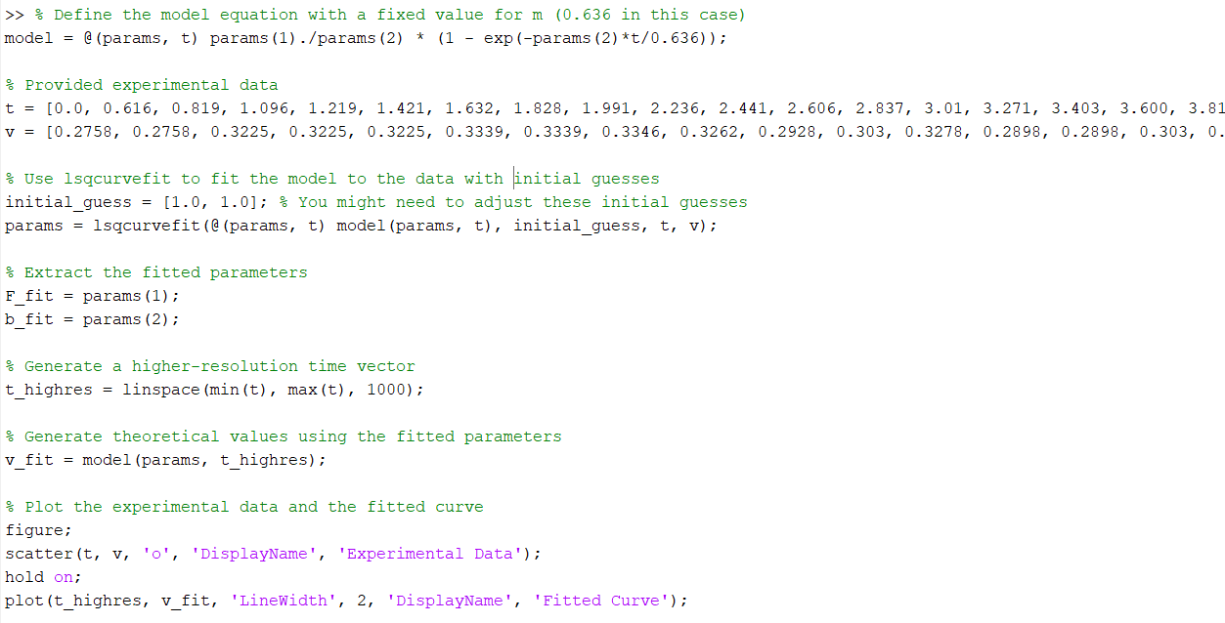
Figure 3
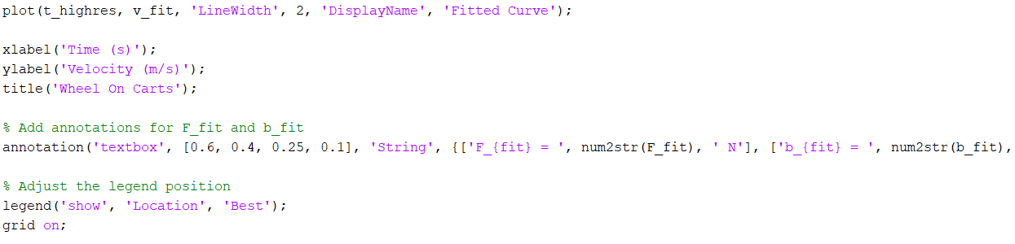
Figure 4

Results

minutes | seconds | speed | Timestamp
55 | 20.494 | 0 | 14:55:20.494
55 | 20.616 | 0.2758 | 14:55:20.616
55 | 20.819 | 0.3225 | 14:55:20.819
55 | 21.096 | 0.3225 | 14:55:21.096
55 | 21.219 | 0.3225 | 14:55:21.219
55 | 21.421 | 0.3339 | 14:55:21.421
55 | 21.632 | 0.3339 | 14:55:21.632
55 | 21.828 | 0.3346 | 14:55:21.828
55 | 21.991 | 0.3262 | 14:55:21.991
55 | 22.236 | 0.2928 | 14:55:22.236
55 | 22.441 | 0.303 | 14:55:22.441
55 | 22.606 | 0.3278 | 14:55:22.606
55 | 22.837 | 0.2898 | 14:55:22.837
55 | 23.010 | 0.2898 | 14:55:23.010
55 | 23.271 | 0.303 | 14:55:23.271
55 | 23.403 | 0.2912 | 14:55:23.403
55 | 23.600 | 0.303 | 14:55:23.600
55 | 23.811 | 0.3329 | 14:55:23.811
55 | 24.068 | 0.3329 | 14:55:24.068
55 | 24.272 | 0.3322 | 14:55:24.272
55 | 24.405 | 0.3179 | 14:55:24.405
55 | 24.608 | 0.2942 | 14:55:24.608
55 | 24.801 | 0.2975 | 14:55:24.801
55 | 25.078 | 0.2975 | 14:55:25.078
55 | 25.209 | 0.3383 | 14:55:25.209
55 | 25.484 | 0.2758 | 14:55:25.484
55 | 25.685 | 0.2758 | 14:55:25.685
55 | 25.809 | 0.3225 | 14:55:25.809
55 | 26.090 | 0.3225 | 14:55:26.090
55 | 26.212 | 0.3225 | 14:55:26.212
55 | 26.416 | 0.3225 | 14:55:26.416
55 | 26.620 | 0.3339 | 14:55:26.620
55 | 26.875 | 0.2917 | 14:55:26.875
55 | 27.078 | 0.3346 | 14:55:27.078
55 | 27.281 | 0.2969 | 14:55:27.281
55 | 27.446 | 0.2928 | 14:55:27.446
55 | 27.612 | 0.303 | 14:55:27.612
55 | 27.847 | 0.3278 | 14:55:27.847
55 | 28.011 | 0.3345 | 14:55:28.011
55 | 28.215 | 0.2898 | 14:55:28.215
55 | 28.460 | 0.2772 | 14:55:28.460
55 | 28.654 | 0.3084 | 14:55:28.654
55 | 28.897 | 0.303 | 14:55:28.897
55 | 29.059 | 0.303 | 14:55:29.059
55 | 29.261 | 0.3329 | 14:55:29.261
55 | 29.465 | 0.3322 | 14:55:29.465
55 | 29.630 | 0.3179 | 14:55:29.630
55 | 29.869 | 0.2975 | 14:55:29.869
55 | 30.066 | 0.2975 | 14:55:30.066
55 | 30.267 | 0.3383 | 14:55:30.267
55 | 30.451 | 0.2758 | 14:55:30.451
55 | 30.675 | 0.2758 | 14:55:30.675
55 | 30.807 | 0.3225 | 14:55:30.807
55 | 31.008 | 0.3225 | 14:55:31.008
55 | 31.279 | 0.3225 | 14:55:31.279
55 | 31.424 | 0.3225 | 14:55:31.424
55 | 31.606 | 0.3339 | 14:55:31.606
55 | 31.807 | 0.2917 | 14:55:31.807
55 | 32.003 | 0.3346 | 14:55:32.003
55 | 32.208 | 0.3262 | 14:55:32.208
55 | 32.411 | 0.2928 | 14:55:32.411
55 | 32.615 | 0.303 | 14:55:32.615
55 | 32.818 | 0.3394 | 14:55:32.818
55 | 33.023 | 0.2898 | 14:55:33.023
55 | 33.220 | 0.2772 | 14:55:33.220
55 | 33.422 | 0.3084 | 14:55:33.422
55 | 33.601 | 0.303 | 14:55:33.601
55 | 33.818 | 0.303 | 14:55:33.818
55 | 34.015 | 0.3329 | 14:55:34.015
55 | 34.246 | 0.3322 | 14:55:34.246
55 | 34.448 | 0.3179 | 14:55:34.448
55 | 34.692 | 0.2942 | 14:55:34.692
55 | 34.845 | 0.2975 | 14:55:34.845
55 | 35.046 | 0.2975 | 14:55:35.046
55 | 35.224 | 0.3383 | 14:55:35.224
55 | 35.446 | 0.2758 | 14:55:35.446
55 | 35.649 | 0.3225 | 14:55:35.649
55 | 35.809 | 0.3225 | 14:55:35.809
55 | 36.009 | 0.3225 | 14:55:36.009
55 | 36.233 | 0.3339 | 14:55:36.233
55 | 36.437 | 0.2917 | 14:55:36.437
55 | 36.658 | 0.2917 | 14:55:36.658
55 | 36.824 | 0.3346 | 14:55:36.824
55 | 37.060 | 0.2969 | 14:55:37.060
55 | 37.224 | 0.2928 | 14:55:37.224
55 | 37.469 | 0.303 | 14:55:37.469
55 | 37.673 | 0.3278 | 14:55:37.673
55 | 37.805 | 0.3394 | 14:55:37.805
55 | 38.081 | 0.2898 | 14:55:38.081
55 | 38.274 | 0.2772 | 14:55:38.274
55 | 38.416 | 0.303 | 14:55:38.416
55 | 38.681 | 0.2912 | 14:55:38.681
55 | 38.876 | 0.303 | 14:55:38.876
55 | 39.075 | 0.3329 | 14:55:39.075
55 | 39.247 | 0.3329 | 14:55:39.247
55 | 39.402 | 0.3322 | 14:55:39.402
55 | 39.666 | 0.3179 | 14:55:39.666
55 | 39.832 | 0.2942 | 14:55:39.832
55 | 40.025 | 0.2975 | 14:55:40.025
55 | 40.227 | 0.2758 | 14:55:40.227
55 | 40.430 | 0.2758 | 14:55:40.430
55 | 40.609 | 0.3225 | 14:55:40.609
55 | 40.828 | 0.3225 | 14:55:40.828
55 | 41.095 | 0.3225 | 14:55:41.095
55 | 41.246 | 0.3225 | 14:55:41.246
55 | 41.450 | 0.3339 | 14:55:41.450
55 | 41.652 | 0.2917 | 14:55:41.652
55 | 41.845 | 0.3346 | 14:55:41.845
55 | 42.049 | 0.2928 | 14:55:42.049
55 | 42.248 | 0.303 | 14:55:42.248
55 | 42.453 | 0.3407 | 14:55:42.453
55 | 42.657 | 0.3394 | 14:55:42.657
55 | 42.846 | 0.2898 | 14:55:42.846
55 | 43.045 | 0.2772 | 14:55:43.045
55 | 43.249 | 0.303 | 14:55:43.249
55 | 43.453 | 0.303 | 14:55:43.453
55 | 43.640 | 0.3329 | 14:55:43.640
55 | 43.881 | 0.3329 | 14:55:43.881
55 | 44.054 | 0.3179 | 14:55:44.054
55 | 44.205 | 0.3179 | 14:55:44.205
55 | 44.407 | 0.2942 | 14:55:44.407
55 | 44.611 | 0.2975 | 14:55:44.611
55 | 44.802 | 0.2758 | 14:55:44.802
55 | 45.049 | 0.3225 | 14:55:45.049
55 | 45.205 | 0.3225 | 14:55:45.205
55 | 45.407 | 0.3339 | 14:55:45.407
55 | 45.610 | 0.2917 | 14:55:45.610
55 | 45.805 | 0.3262 | 14:55:45.805
55 | 46.036 | 0.2928 | 14:55:46.036
55 | 46.239 | 0.3278 | 14:55:46.239
55 | 46.401 | 0.3345 | 14:55:46.401
55 | 46.603 | 0.2772 | 14:55:46.603
55 | 46.807 | 0.2912 | 14:55:46.807
55 | 47.009 | 0.3329 | 14:55:47.009
55 | 47.212 | 0.3179 | 14:55:47.212
55 | 47.408 | 0.2975 | 14:55:47.408
55 | 47.613 | 0.2758 | 14:55:47.613
55 | 47.859 | 0.3225 | 14:55:47.859
55 | 48.022 | 0.3225 | 14:55:48.022
55 | 48.226 | 0.3339 | 14:55:48.226
55 | 48.431 | 0.3346 | 14:55:48.431
55 | 48.635 | 0.2928 | 14:55:48.635
55 | 48.825 | 0.3407 | 14:55:48.825
55 | 49.089 | 0.3345 | 14:55:49.089
55 | 49.229 | 0.2898 | 14:55:49.229
55 | 49.404 | 0.2772 | 14:55:49.404
55 | 49.617 | 0.303 | 14:55:49.617
55 | 49.839 | 0.2912 | 14:55:49.839
55 | 50.007 | 0.303 | 14:55:50.007
55 | 50.273 | 0.3329 | 14:55:50.273
55 | 50.487 | 0.2907 | 14:55:50.487
55 | 50.667 | 0.3179 | 14:55:50.667
55 | 50.867 | 0.2942 | 14:55:50.867
55 | 51.066 | 0.2975 | 14:55:51.066
55 | 51.229 | 0.2975 | 14:55:51.229
55 | 51.422 | 0.2758 | 14:55:51.422
55 | 51.627 | 0.2758 | 14:55:51.627
55 | 51.867 | 0.3225 | 14:55:51.867
55 | 52.016 | 0.3225 | 14:55:52.016
55 | 52.212 | 0.3225 | 14:55:52.212
55 | 52.419 | 0.3339 | 14:55:52.419
55 | 52.606 | 0.2917 | 14:55:52.606
55 | 52.824 | 0.2917 | 14:55:52.824
55 | 53.003 | 0.3346 | 14:55:53.003
55 | 53.225 | 0.3262 | 14:55:53.225
55 | 53.470 | 0.2928 | 14:55:53.470
55 | 53.635 | 0.303 | 14:55:53.635
55 | 53.837 | 0.3407 | 14:55:53.837
55 | 54.029 | 0.3394 | 14:55:54.029
55 | 54.206 | 0.2898 | 14:55:54.206
55 | 54.417 | 0.2772 | 14:55:54.417
55 | 54.618 | 0.3084 | 14:55:54.618
55 | 54.822 | 0.303 | 14:55:54.822
55 | 55.022 | 0.303 | 14:55:55.022
55 | 55.290 | 0.3329 | 14:55:55.290
55 | 55.443 | 0.2907 | 14:55:55.443
55 | 55.646 | 0.3179 | 14:55:55.646
55 | 55.851 | 0.2758 | 14:55:55.851
55 | 56.088 | 0.3225 | 14:55:56.088
55 | 56.287 | 0.3225 | 14:55:56.287
55 | 56.454 | 0.3225 | 14:55:56.454
55 | 56.654 | 0.3225 | 14:55:56.654
55 | 56.859 | 0.3225 | 14:55:56.859
55 | 56.074 | 0.3339 | 14:55:56.074
55 | 57.269 | 0.2917 | 14:55:57.269
55 | 57.480 | 0.3346 | 14:55:57.480
55 | 57.664 | 0.3262 | 14:55:57.664
55 | 57.869 | 0.2928 | 14:55:57.869
55 | 58.015 | 0.303 | 14:55:58.015
55 | 58.220 | 0.3407 | 14:55:58.220
55 | 58.401 | 0.3278 | 14:55:58.401
55 | 58.645 | 0.2898 | 14:55:58.645
55 | 58.808 | 0.2772 | 14:55:58.808
55 | 59.007 | 0.303 | 14:55:59.007
55 | 59.205 | 0.2912 | 14:55:59.205
55 | 59.405 | 0.303 | 14:55:59.405
56 | 59.609 | 0.3329 | 14:55:59.609
56 | 59.811 | 0.2907 | 14:55:59.811
56 | 00.016 | 0.3179 | 14:56:00.016
56 | 00.213 | 0.2942 | 14:56:00.213
56 | 00.403 | 0.2975 | 14:56:00.403
56 | 00.682 | 0.3179 | 14:56:00.682
56 | 00.886 | 0.2942 | 14:56:00.886
56 | 01.039 | 0.2975 | 14:56:01.039
56 | 01.222 | 0.2975 | 14:56:01.222
56 | 01.497 | 0.2758 | 14:56:01.497
56 | 01.619 | 0.3225 | 14:56:01.619
56 | 01.883 | 0.3225 | 14:56:01.883
56 | 02.028 | 0.3225 | 14:56:02.028
56 | 02.214 | 0.3225 | 14:56:02.214
56 | 02.435 | 0.3225 | 14:56:02.435
56 | 02.638 | 0.3339 | 14:56:02.638
56 | 02.843 | 0.2917 | 14:56:02.843
56 | 03.088 | 0.3346 | 14:56:03.088
56 | 03.250 | 0.3262 | 14:56:03.250
56 | 03.455 | 0.2928 | 14:56:03.455
56 | 03.661 | 0.303 | 14:56:03.661
56 | 03.862 | 0.3407 | 14:56:03.862
56 | 04.005 | 0.3345 | 14:56:04.005
56 | 04.229 | 0.2898 | 14:56:04.229
56 | 04.456 | 0.2772 | 14:56:04.456
56 | 04.641 | 0.303 | 14:56:04.641
56 | 04.862 | 0.3084 | 14:56:04.862
56 | 05.005 | 0.303 | 14:56:05.105
56 | 05.268 | 0.3329 | 14:56:05.268
56 | 05.465 | 0.2907 | 14:56:05.465
56 | 05.609 | 0.3179 | 14:56:05.609
56 | 05.869 | 0.2942 | 14:56:05.869
56 | 06.047 | 0.2975 | 14:56:06.047
56 | 06.268 | 0.2975 | 14:56:06.268
56 | 06.416 | 0.2758 | 14:56:06.416
56 | 06.681 | 0.2758 | 14:56:06.681
56 | 06.804 | 0.3225 | 14:56:06.804
56 | 07.088 | 0.3225 | 14:56:07.088
56 | 07.210 | 0.3225 | 14:56:07.210
56 | 07.404 | 0.3225 | 14:56:07.404
56 | 07.690 | 0.3339 | 14:56:07.690
56 | 07.813 | 0.2917 | 14:56:07.813
56 | 08.017 | 0.3346 | 14:56:08.017
56 | 08.221 | 0.3262 | 14:56:08.221
56 | 08.406 | 0.2928 | 14:56:08.406
56 | 08.629 | 0.303 | 14:56:08.629
56 | 08.811 | 0.3278 | 14:56:08.811
56 | 09.045 | 0.3345 | 14:56:09.045
56 | 09.228 | 0.2898 | 14:56:09.228
56 | 09.430 | 0.2772 | 14:56:09.430
56 | 09.635 | 0.303 | 14:56:09.635
56 | 09.839 | 0.2912 | 14:56:09.839
56 | 10.039 | 0.303 | 14:56:10.039
56 | 10.204 | 0.3329 | 14:56:10.204
56 | 10.426 | 0.3322 | 14:56:10.426
56 | 10.610 | 0.2758 | 14:56:10.610
56 | 10.831 | 0.2758 | 14:56:10.831
56 | 11.033 | 0.3225 | 14:56:11.033
56 | 11.220 | 0.3225 | 14:56:11.220
56 | 11.435 | 0.3225 | 14:56:11.435
56 | 11.639 | 0.3225 | 14:56:11.639
56 | 11.841 | 0.3225 | 14:56:11.841
56 | 12.005 | 0.3339 | 14:56:12.005
56 | 12.241 | 0.2917 | 14:56:12.241
56 | 12.425 | 0.3346 | 14:56:12.425
56 | 12.648 | 0.3262 | 14:56:12.648
56 | 12.812 | 0.2928 | 14:56:12.812
56 | 13.057 | 0.303 | 14:56:13.057
56 | 13.261 | 0.3278 | 14:56:13.261
56 | 13.415 | 0.3394 | 14:56:13.415
56 | 13.657 | 0.2898 | 14:56:13.657
56 | 13.819 | 0.2772 | 14:56:13.819
56 | 14.059 | 0.303 | 14:56:14.059
56 | 14.215 | 0.2912 | 14:56:14.215
56 | 14.417 | 0.303 | 14:56:14.417
56 | 17.174 | 0 | 14:56:17.174
Figure 5 table showing the autocross speed and time values every 0.2 seconds for one lap.
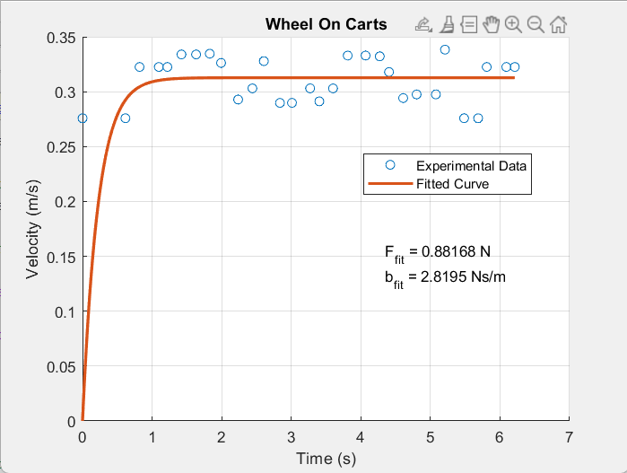
Figure 6 lab 4 Matlab experimental graph
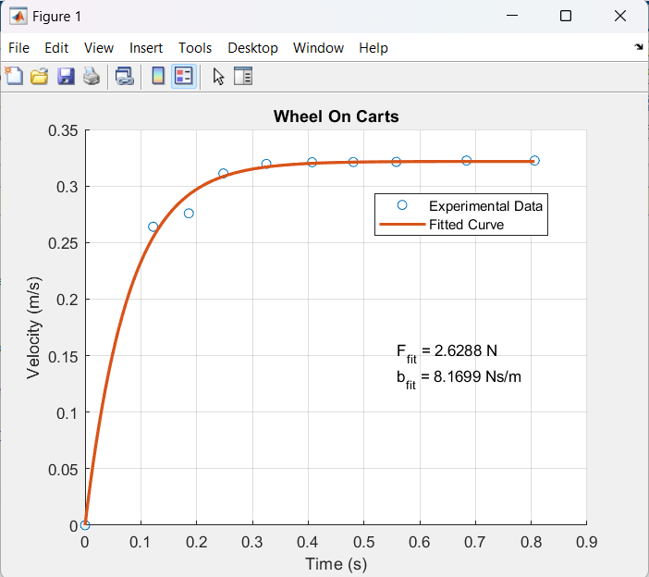
Figure 7 lab 3 Matlab experimental graph

Discussion and Conclusion
The model is described by the equation:
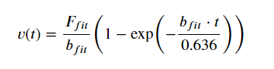
After applying the least squares curve fitting algorithm to the experimental data, we obtained the following fitted parameters:
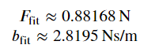
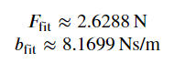
These parameters represent the force and damping coefficient, respectively, in the context of the model. The curve generated by the fitted model closely matches the experimental data, as illustrated in the plotted graph.
This analysis provides insights into the dynamics of the system under investigation, particularly the forces involved and the damping effect on the velocity-time relationship. The accuracy of the fitted parameters depends on the quality of the experimental data and the appropriateness of the chosen model. Further experiments and analysis may refine these findings and contribute to a more comprehensive understanding of the system.

